Transact Now

1.Purchase/Subscription: buying units or shares in one of the mutual fund schemes offered by HDFC Asset Management Company.which pools money from various investors to invest in a diversified portfolio of stocks, bonds, or other assets, depending on the scheme's objective.

There are 2 types
i) SIP
ii) Lumpsum Purchase
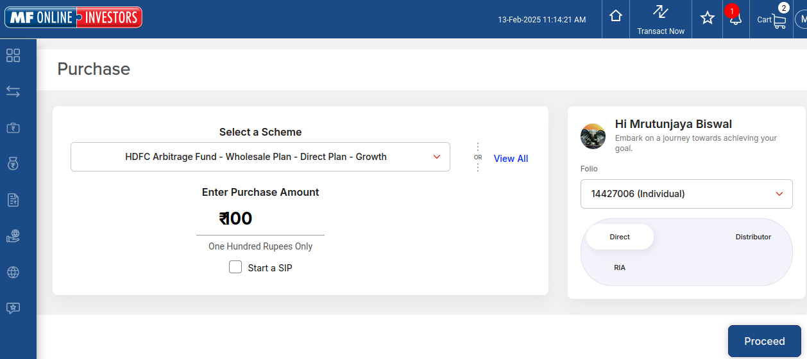
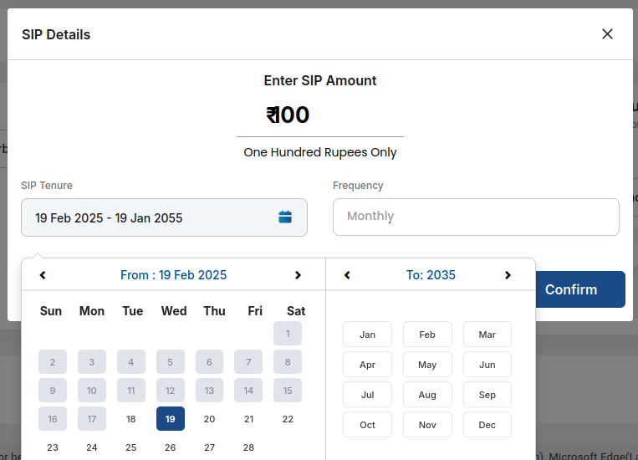
Flow of Purchase:
1. 1st we have to login in HDFC AMC .
2. Click on transact now button.
3. Select investment type purchase
4. Select scheme (if we select IDCW Scheme then payout and reinvest option is displayed).
5. Enter purchase amount
6. Click on start a SIP checkbox.
7. Pop up message show as SIP details.
8. Enter SIP amount.
9. Set SIP tenure (Bydefault it will suggest tenure period 30 yrs.)
10. Click on confirm button.
11.Click on Proceed button.
12.Send OTP on registered mobile number and email id.
13. Click on confirm button. Then it will redirect to the choose your payment option page.
14.There are 2 options UPI Autopay and Existing bank mandate.
14. Select Bank
15. Accept terms and conditions, Click on Checkbox.
16.click on Pay Now button. It will redirect to the review page of the SIP.

2.SIP (Systhematic Investment Plan): SIP is a way of invest in mutual fund ,it investing a fixed amount in regular interval.

Flow of SIP:
1.Click on transact now button.
2.Select SIP (Systhematic Investment Plan).
3.Select SIP scheme.
4.Enter SIP amount.
5.Set SIP tenure.
6.Select frequency (Daily, weekly, monthly, quaterly,half yearly, Yearly)
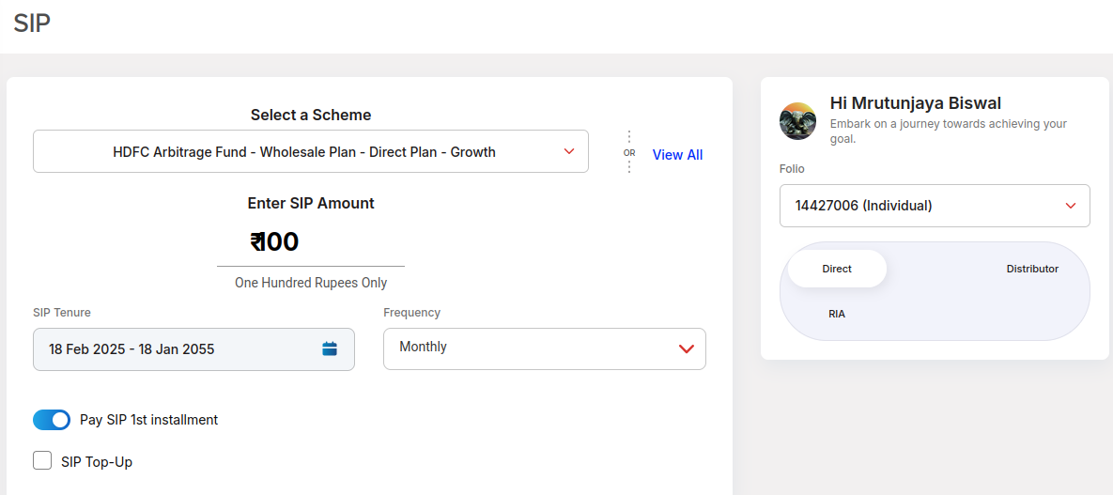

7. Investor has option to pay the 1st installment today(toggle button Pay SIP 1st installment)
8.Select the SIP Top-up checkbox.
9. SIP Top-up page is displayed.
10. In SIP Top up page amount is autofetch
11.Select frequency (Yearly , Half yearly)
12.Select SIP Top up cap amount
13.Set the Cap month year.
14. Click on save button.
15. Click on proceed button.
16.Send OTP on registered mobile number and email id.
17.Click on confirm button. Then it will redirect to the choose your payment option page.
14.There are 2 options UPI Autopay and Existing bank mandate.
14. Select Bank
15. Accept terms and conditions, Click on Checkbox.
16.click on Pay Now button. It will redirect to the review page of the SIP.

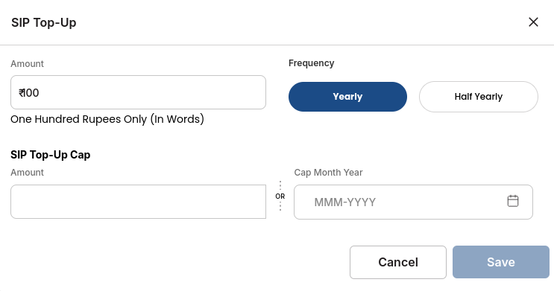

3.Flex SIP: Allows investors to adjust their investment amount based on market conditions.
e.g.Monthly installment is 5000 and tenure is 3 years so total amount is 1,80,000,suppose if you start flex SIP in Jan & after april market is decrease &you will loss 3000 Rs. So amount will deducted is 8000 (max amount is deducted twice of SIP installment amount). In 35th installment if your amount is fill then SIP will close at 35th installment that is the main difference in SIP & Flex SIP.

Work Flow of Flex SIP:
1.Click on transact now.
2.Select on Flex SIP
3.Select on existing folio no.
4.Select invest through i)Direct ii)Distributor iii)RIA
5. Select direct
6. Add scheme
7. Select installment frequency (Monthly , quaterly)
8. Select monthly
9.Bydefault SIP amount selected Rs.5000
10. Do you wish to pay first installment with your SIP Registration, Select Yes or NO option.
11.Select payment option – OTM and Register E-Mandate (eOTM)
12.Click on select bank
13.Installment date details start date by default select flex SIP date T+7.
14.Select Tenure -(
15.Click on proceed to transact and redirect to the review page.
16.Click on terms and condition and click on complete trasaction.
17. OTP will be generate and verify.
4.STP (Systhematic Transfer Plan): It is a strategy that allows you to transfer a fixed amount or percentage of your investment from one mutual fund to another mutual fund, within the same fund house, at regular interval (monthly , quaterly) T+9 -Monthly as per HDFC.
e.g.If you have instead a lumpsum amount in a debt fund and want to move a portion of it to an equity fund overtime, you can set up an STP. (Daily, Weekly, monthly, quaterly – In HDFC).

Flow of the STP:
1.Click on transact now
2.Select STP
3.Select invest through option- i)Direct , ii)Distributor, iii)RIA
4.Select STP type – i)Normal STP ii) Flex STP
5.Select Folio
6.Select source scheme
7.Select target scheme
8.Select IDCW option
9.Select STP type
10. Select Frequency
11. Select day
12. Enter no.of installment
13. Enter STP amount

5.Flex STP: Allows investor to transfer variable amount from one mutual fund scheme to another mutual fund scheme based on market conditions.

6.Switch: A one time transfer of your entire or partial investment from one scheme to another scheme within the same fund house.
e.g.Moving 1 lacs from an equity fund to debt fund in one time.
Equity- T+3
Debt- T+2
Liquid- T+2

Flow of Switch:
1.Select investment Mode – Direct
2.Select folio no. Then select scheme- source scheme’s
3.select scheme from target scheme – growth and IDCW
4. Select value – amount, All free units, no. Of units
5. Enter amount
6. Click on proceed transactions
7. Redirect to the review page.
8. Click on checkbox terms and conditions
9. Complete the transactions
10. Generate the otp and verify

7.Redeem: Redeem means selling and withdrawing your mutual fund units for cash.when you redeem ,the mutual fund company buys back your units at the Net Asset Value(NAV) of that day.
-Withdraw amount at one time within 3 working days received in investor bank account.

Flow of Redeem:
1.Click on transact now.
2.Select redeem option
3.select folio
4.select scheme
5.Select value i)Amount ii) All free units iii) No. Of units
6.We can withdraw minimum 100 Rs.
7.We can not exceed value of clear units available to redeem.
8. Select bank
9. We have option i)Save ii) Schedule transaction iii)Proceed to transact.

8.Insta Redeem/ Instant Access Facility: Insta redeem means selling and withdrawing your mutual fund money from their liquid funds immediately.
This is done through the immediate payment service(IMPS) facility.

How does it work?
-Investor can redeem up to Rs.50,000 or 90% of their investment amount in liquid funds per day, whichever is lower. (Min Rs. 5000 can redeem)
-The amount is transferred to the investors linked bank account instantly.
-For other withdrawal amount, the redemption request is processed within 1 to 2 business days.

9.SWP (Sythematic Withdraw Plan): It is a reverse of an SIP or STP, where instead of investing money into a mutual fund at regular interval, you set up a plan to withdraw a fixed amount of money from your mutual fund at regular interval ( monthly , quaterly, etc).

Work Flow of SWP:
1.Select folio no
2.Select SWP type – fixed amount / Capital appreciation
3.Select source scheme
4.Select withdrawal optional
5.Select frequency (monthly, quaterly,half yearly, Yearly)
6.Enter swap amount
7.Select start date and End date (T+10) monthly , quaterly, halfyearly, Yearly
8.Select bank for payout – bydefault bank is selected
9.Click on proceed and redirect to review page.
10. Click on checkbox terms and conditions and click on complete transactions
11. OTP will be generate and verify

10.Dream SIP: It is a market based long term capital growth and regular income solution as per your choice
Dream SIP = SIP +SWP
There are two options
Option A: SIP and SWP from same scheme
Option B: SIP and SWP from different scheme

Option A: If you invest in SIP then after complition of tenure we can withdraw amount (Lumpsum amount also) until amount thats ends (frequency is only monthly for this option)

Option B: In this option after complition of SIP from source scheme to target scheme (frequency is only monthly)
Tenure for both option 7, 10, 12, 15, 20,25,30 yrs.
Premature withdrawal is available and SIP top up also available
Minimum monthly SIP is Rs. 100

SIP Tenure Monthly swap installment amount
7 Years 1.0 times initial monthly sip installment amount
10 Years 1.5 times initial monthly sip installment amount
12 Years 2.0 times initial monthly sip installment amount
15 Years 3.0 times initial monthly sip installment amount
20 Years 5.0 times initial monthly sip installment amount
25 Years 8.0 times initial monthly sip installment amount
30 Years 12.0 times initial monthly sip installment amount

11.Swap (Systematic Withdrawal Advantage Plan): Swap is a feature of HDFC Mutual fund that allows investors to withdraw money from their mutual fund investment at regular intervals.

How does SWAP work?
-Investor can choose between a fixed plan or a variable plan.
-With a fixed plan, investors withdraw a fixed sum of money at regular intervals.
-With a veriable plan , investors withdraw a variable amount of money at regular intervals.
Withdrawals are subject to tax at saurce, if applicable.

12.Smart Swap: Allows investor to withdraw a specific percentage of a decided corpus at regular intervals subject to the and conditions of specified duration.

13. Change IDCW option: We can change scheme type payout to Re-investment.

14. Transfer IDCW Plan(TIP): In this plan you can receive returns at regular intervals from your investments. We can transfer a IDCW scheme to IDCW scheme transfer.

15. Flex Index: It is a facility provided to the unit holders of source scheme to set triggers based on the predetermined event to enable HDFC mutual fund.

16. Roll Over:

